Sicangu Wicoti Awanyakape
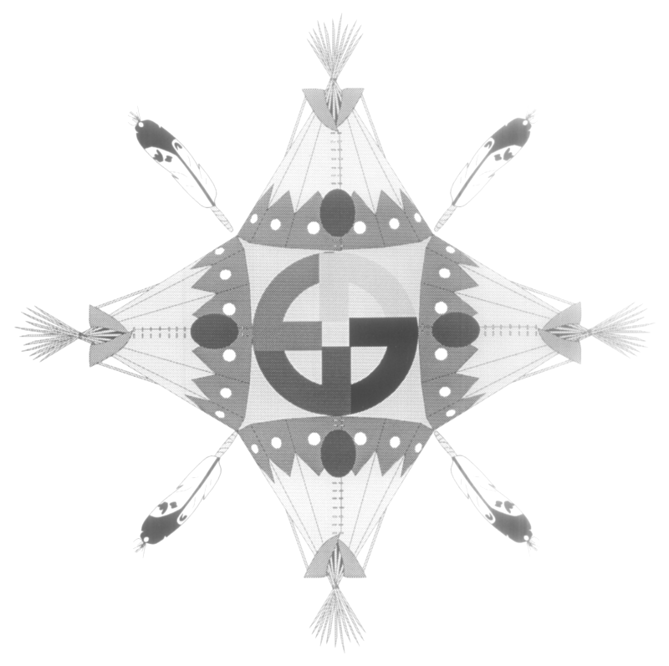
S. W. A. Corporation
P.O. Box 69
Rosebud, South Dakota 57570
Phone: 605-747-2203 Fax: 605-747-2966
Toll Free: 1-888-379-3411

PET RESTRICTION NOTICE

PLEASE TAKE NOTICE: This notice is being sent as a reminder of the pet restrictions tenants have agreed to abide by. The following provisions of your duly executed Lease with S.W.A. Corporation, the Dwelling Lease and Rules of Occupancy, signed by you state the following:

DWELLING LEASE
Lease Sec. 10 (S) Tenant agrees to all other rules and regulations imposed by Landlord that are currently adopted in the future as long as such rules and regulations are made known to Tenant, or an adult member of Tenant’s household, in writing or by posting in a conspicuous place at the Landlords offices.

RULES OF OCCUPANCY
POSTED AND ADOPTED AUGUST 05, 1991
Sec 6 Only one Dog or Cat, no fowls or other animals may be kept on the premises, Songbirds accepted. (Dog must be kept on leash and/or in fenced area).
Reasonable Requirements
SWA has established reasonable requirements related to pet ownership including, but not limited to:
Prohibitions on types of animals that the S.W.A classifies as dangerous, provided that such classifications are consistent with applicable local law
S.W.A. Policies – Housing Management- 15.5.18Pets
iii. SWA prohibits types of dogs that the public perceives as dangerous or are of a vicious nature including, but not limited to Pit Bull or Pit Bull mix, Rottweiler or Rottweiler mix, German Shepherds, Doberman Pincers; vi. No feeding of strays, temporary housing of strays, or any other type of encouraging strays to stay in the community shall not be allowed.
Any serious reports received of viscous dogs or attacks will warrant a Lease violation that can also lead to a Lease termination depending on the circumstances.

Should you have any questions or concerns please feel free to contact your SWA Occupancy Specialist (605) 747-2203. Your cooperation would be greatly appreciated in this matter.

15.5.18 Pets
SWA’s rules regarding pets are reasonable related to the legitimate interest of SWA to provide a decent, safe and sanitary living environment for all tenants, and to protect and preserve the physical condition of the property, as well as the financial interest of SWA. Requirements related to pet ownership including, but are not limited to:
- No livestock or poultry of any kind shall be raised, bred or kept on the premises, song birds accepted;
- Only one dog or cat may be kept on the premises;
- SWA prohibits types of dog that the public perceives as dangerous or are of a vicious nature including but not limited to Pit Bull or Pit Bull mix, Rottweiler or Rottweiler mix, German Sheperds, Doberman Pincers;
- Pests must be well mannered, non-aggressive, and quiet so as not to disturb the neighbor’s peaceful enjoyment of their unit;
- Pet owners will be responsible for any damage to their unit, the community facilities, neighbors property, or injuries to other persons, caused by their pet;
- No feeding of strays, temporary housing of strays, or any other type of encouraging strays to stay in the community shall not be allowed;
- Pet approval required by SWA prior to being brought onto the premises.
- Information to be renewed upon reexamination.
15.5.19 When a breach of the Agreement has been identified, SWA shall discuss the noncompliance with the Homebuyer/Tenant as well as providing the family with written notification identifying the breach, and giving the Homebuyer/Tenant an opportunity to identify any extenuating circumstances, and an opportunity to enter into a plan of action to correct the breach. If requested by the Homebuyer/Tenant, a plan of action shall be agreed upon specifying how the homebuyer/tenant will come into compliance, as well as any actions by SWA that may be appropriate and a deadline for the plan’s completion. The plan of action will be signed by the SWA representative and the Homebuyer/Tenant.

